How to use ADD-Vantage® Vial System
Due to severe shortage with the Minibag Plus ® system, pharmacy will be providing some medications such as Cefazolin and Zosyn® for use with ADD-Vantage® system. See below instructions that detail for use. Contact the unit pharmacist if any further questions.

To Assemble Vial and Flexible Diluent Container  (Use Aseptic Technique): | To Prepare Admixture:
1. Remove the protective covers from the top of the vial and the vial port on the diluent container as follows:  a. To remove the breakaway vial cap, swing the pull ring over the top of the vial and pull down far enough to start the opening (SEE FIGURE 1.), then pull straight up to remove the cap. (SEE FIGURE 2.) NOTE: Once the breakaway cap has been removed, do not access vial with syringe.  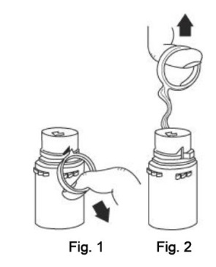  b. To remove the vial port cover, grasp the tab on the pull ring, pull up to break the three tie strings, then pull back to remove the cover. (SEE FIGURE 3.)  2. Screw the vial into the vial port until it will go no further. THE VIAL MUST BE SCREWED IN TIGHTLY TO ASSURE A SEAL. This occurs approximately½ turn (180°) after the first audible click. (SEE FIGURE 4.) The clicking sound does not assure a seal; the vial must be turned as far as it will go. NOTE: Once vial is seated, do not attempt to remove. (SEE FIGURE 4.)  3. Recheck the vial to assure that it is tight by trying to turn it further in the direction of assembly.  4. Label appropriately.  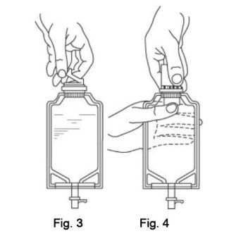 | 1. Squeeze the bottom of the diluent container gently to inflate the portion of the container surrounding the end of the drug vial.  2. With the other hand, push the drug vial down into the container telescoping the walls of the container. Grasp the inner cap of the vial through the walls of the container. (SEE FIGURE 5.)  3. Pull the inner cap from the drug vial. (SEE FIGURE 6.) Verify that the rubber stopper has been pulled out, allowing the drug and diluent to mix.  4. Mix container contents thoroughly and use within the specified time.  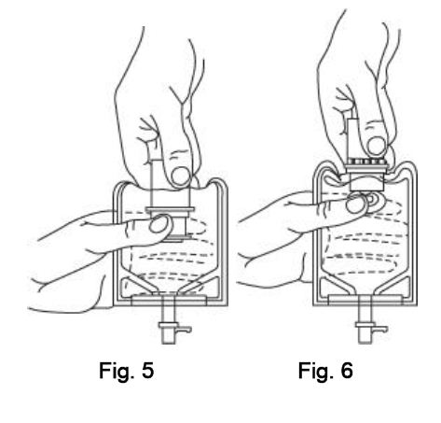  5. Confirm the activation and admixture of vial contents.  6. Check for leaks by squeezing container firmly. If leaks are found, discard unit as sterility may be impaired.  Video Information Resource: https://www.youtube.com/watch?v=aFoHldOybZ8  UConn Health Department of Pharmacy  Last Updated 9/27/2017

