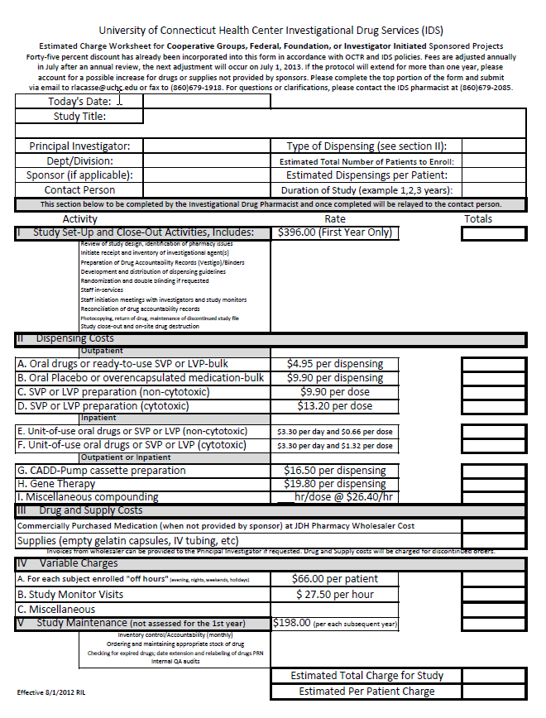

- Approved [ 12/28/2012]
- Revised [ 10/25/2015, 9/1/2017]

