UConn John Dempsey Hospital
Department of Pharmacy Services

M E M O R A N D U M

To: All JDH Prescribers and Nursing Staff
From: Department of Pharmacy
RE: Local Anesthetic Shortage Update: Lidocaine
Date: June 20, 2018

All injectable presentations of the following products continue on national drug shortage:
- Lidocaine (plain)
- Lidocaine Preservative Free
- Lidocaine with Epinephrine
- Bupivacaine (plain)
- Bupivacaine Preservative Free
- Bupivacaine with Epinephrine
The pharmacy is currently at critical supply of all presentations of lidocaine (plain) and lidocaine preservative free. Additional supply of these products is sporadically available through the wholesaler for the pharmacy department.
Currently, some supply of various sizes of lidocaine with epinephrine, bupivacaine (plain), bupivacaine preservative free, and bupivacaine with epinephrine is available in the pharmacy with limited additional product available for purchase. The Pharmacy Department is working diligently to obtain any product available. Please anticipate changes in product availability until the resolution of these shortages. Contact the Pharmacy Department to determine availability.

See a comparison¹ of the two agents below. Note that, in general, bupivacaine is longer acting, while lidocaine has a more rapid onset, but shorter duration of action.
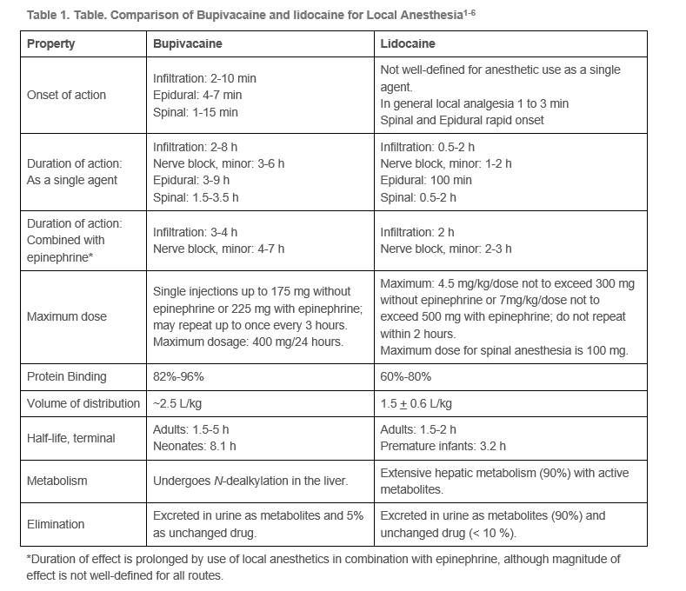
Additional information regarding the national shortage is available from the American Society of Health-System Pharmacists (ASHP):
¹Lidocaine- https://www.ashp.org/drug-shortages/current-shortages/Drug-Shortage-Detail.aspx?id=88
Bupivacaine- https://www.ashp.org/Drug-Shortages/Current-Shortages/Drug-Shortage-Detail.aspx?id=172

