Procalcitonin Levels and Clinical Interpretation
Procalcitonin (PCT) is a sensitive and specific biomarker that can assist the clinician in the diagnosis and treatment of bacterial infection. Procalcitonin has been studied most thoroughly for lower respiratory tract infections (LRTI) and sepsis and its use is associated with decreased antimicrobial usage no negative impacts on clinical outcomes.
At UConn Health, starting November 1st, procalcitonin can be ordered for ED patients and inpatients only. It is available for order 24 hours a day, seven days a week with an estimated turn around time of 20 minutes to one hour. Testing will be monitored by our antibiotic stewardship program.

Test Interpretation – with each result the following ranges and comments will be included
Normal | <0.1 ng/mL | Reference value. Normal. Antibiotics discouraged.
Suspected Lower Respiratory Tract Infection or Suspected Sepsis* | 0.1-0.25 ng/mL | Low likelihood of bacterial infection; antibiotics discouraged
 | >0.25 ng/mL | Increased likelihood of bacterial infection; antibiotics encouraged
 | >0.5 ng/mL | Strong likelihood of bacterial infection; antibiotics strongly encouraged
*Consider initiating antibiotics in ALL clinically unstable patients.
Key Principles for Interpretation of PCT Test Results
Interpret in the clinical context of the patient. Patients with septic shock should not have antibiotics withheld based solely on a normal PCT.
Serial measurements are preferred and provide more useful information. Patients may have a normal PCT value very early in the development of a bacterial infection. Patients who have persistently normal PCT levels are unlikely to have bacterial infection. PCT levels should not be drawn more often than every 3 days. For patients with elevated measurements that decrease rapidly (>80%) on repeat measurements antibiotic cessation should be considered in absence of an identified bacterial infection.
Consider the dynamics of the disease. Patients with severe trauma without infection should have PCT levels which steadily decline. Patients with rising PCT levels suggest a lack of control of an infection. PCT levels will generally take longer to normalize in patients with severe infections (e.g., bacteremic pneumonia).
Be aware of conditions which may affect PCT levels. Patients with peritonitis who return to the OR for a washout are expected to have a transitory increase in PCT value post-operatively but should continue to trend down if the infection is adequately controlled.
There are patient populations in which PCT results are less reliable. These include: pregnancy, severely immunocompromised patients (chemotherapy, radiation, immunosuppressive therapy other than steroids), severe neutropenia, chronic infections (endocarditis, osteomyelitis), massive stress, severe left heart failure, resuscitated cardiac arrest, continuous renal replacement therapy.
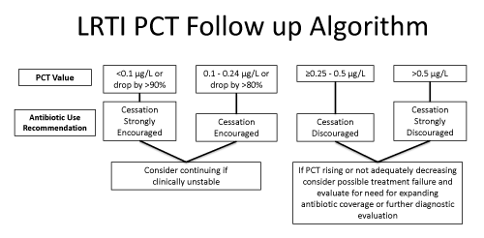
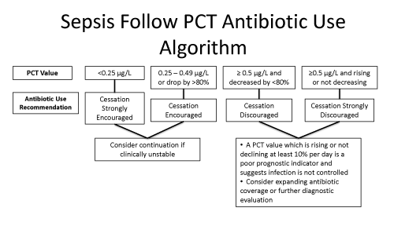References:
1. Procalcitonin (PCT) Guidance. Nebraska Medicine Website. https://www.nebraskamed.com/for-providers/asp/procalcitonin-pct-guidance. Last updated: September 12, 2017. Accessed October 20, 2017.
2. Li H, et al. Meta-analysis and systematic review of procalcitonini-guided therapy in respiratory tract infections. Antimicrob Agents Chemother. 2011;55:5900-6.
3. Kopterides P, et al. Procalcitonin-guided algorithms of antibiotic therapy in the intensive care unit: a systematic review and meta-analysis of randomized controlled trials. Crit Care Med. 2010;38:2229-4
Prepared by Megan Mitchell, PharmD

