3.erwesss  Add dosing interval to time trough was taken  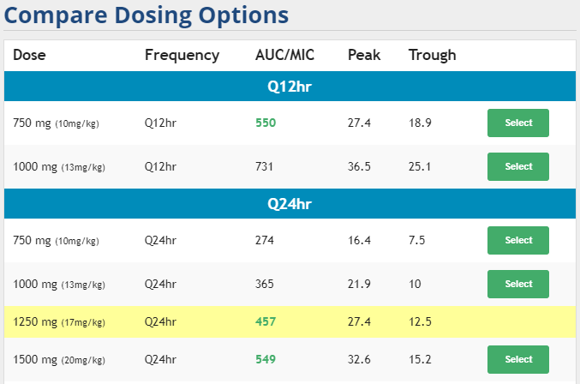  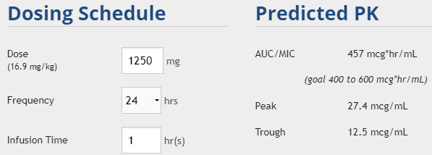  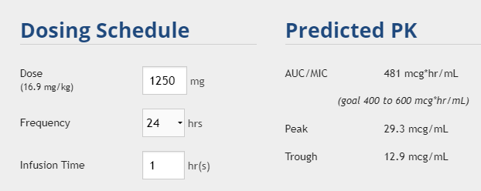  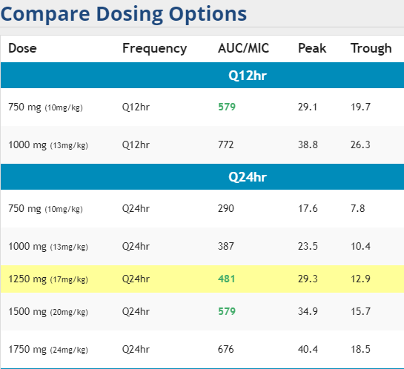  Assessing Drug Levels  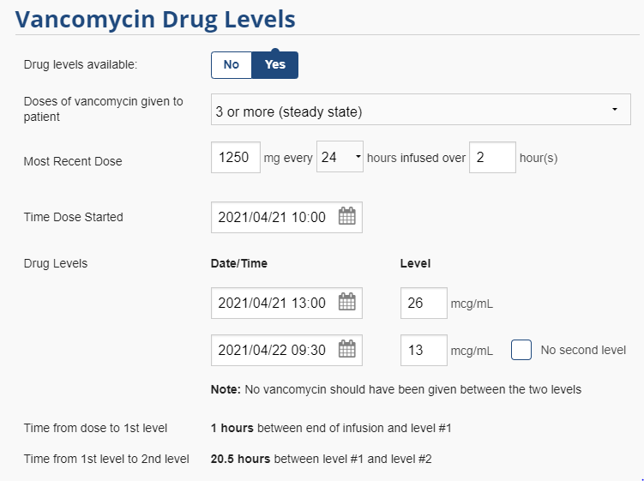  Determining Initial Maintenance Regimen  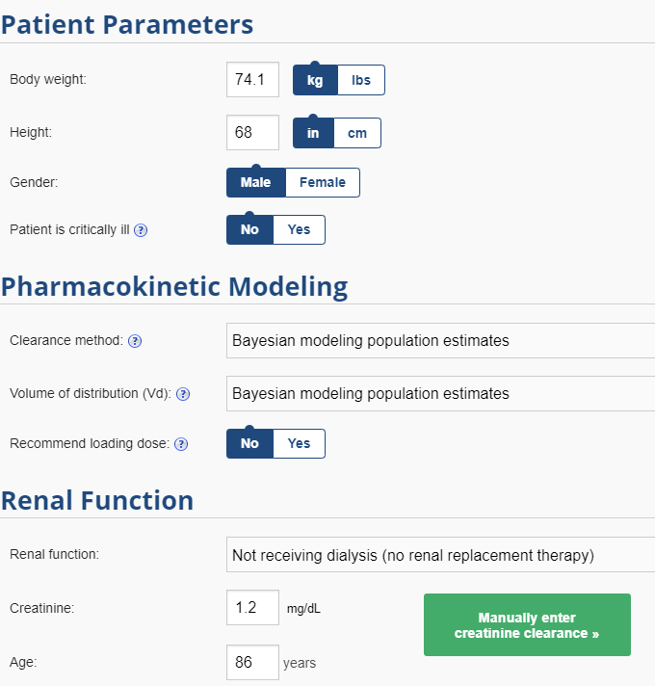 | Vancomycin Collaborative Practice (VCP)  Pocket Guide for  Pharmacists  Please refer to additional files on the health.uconn.edu/pharmacy website for more detailed information and for all necessary forms.  UConn Health Department of Pharmacy & Antimicrobial Stewardship Program

Vancomycin Loading Dose: All Patients  - 25 mg/kg based on total body weight not to exceed 3000 mg  Add dosing interval to trough level was taken  Scheduling Labs  - Trough: blood draw should be scheduled 1 hour prior to the start of an infusion of a dose  - Peak: blood draw should be scheduled to occur 1-2 hours after the end of the same dose infusion  - Example  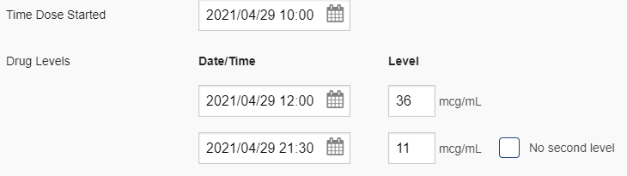  Clinical Situations that May Require Monitoring PRIOR TO 72 HOURS  - Critically-ill patients (ICU patients) with or without hemodynamic stability  - Patients with a BMI > 40  - Patients with documented positive blood cultures for gram-positive cocci and/or patients with suspected pneumonia and a positive MRSA PCR nasal swab  - Patients with substantial acute alterations in renal function  - Patient on HD or other continuous renal replacement  - Patients with anticipated hospital discharge prior to 72 hours of therapy who need outpatient vancomycin therapy  Therapeutic Monitoring:  - AUC range of 400-600 mg-h/L will be used for ALL PATIENTS  - Vancomycin levels may ONLY be assessed if therapy continues for at least 3 days (72 hours)  Initial Vancomycin Maintenance Regimen  - Dose: 500 mg to 2000 mg  - Maximum initial single administered dose of 2000 mg per dose; maximum total daily dose of 4000 mg per day  - Administration Intervals: Every 8, 12, 24, 48, or 72 hours |  | MRSA Nasal Swab  - RPh may order MRSA nasal swab if a patient has documented/suspected pneumonia may discontinue Vancomycin if negative  - To order, go to Orders tab in the patient’s chart and type “MRSA”  - RPh should contact primary care team to alert of discontinuation  *Doses available at UConn Health: 500, 750, 1000, 1250, 1500, 1750, 2000, 2500, and 3000 mg
   | Time | Level
  Trough | 09:30 | 11
  Dose: 1000 mg every 12 hours | 10:00 | __
  Peak | 12:00 | 36
  Table #3: Infusion Times for Vancomycin Doses
  Doses | Infuse Over
  500-1000 mg | 1 hour
  1250-1750 mg | 2 hours
  Doses ≥ 2000 mg | 2.5 hours
  Table #2: Guidelines for Regimens Adjustments in Hemodialysis Patients
  Pre-HD Conc. (mg/L) | Next Vancomycin Dose
  5-10 | Increase maintenance dose by ~50%
  10-14 | Increase maintenance dose by ~25%
  15-20 | No change in maintenance dose
  21-25 | Decrease maintenance dose by ~25%
  26-30 | Decrease maintenance dose by ~50
  >30 | Consider holding next dose or decrease dose by ~75
  Table #1: Special Dosing Considerations and Suggested Changes to Vancomycin Dosing
  Special Dosing Considerations | Effect on Vancomycin | Suggested Changes/Notes
  Chronic or Acute Hemodialysis (HD) | Increased Vd  A 3-4h HD session usually eliminate ~30-50% of the serum concentration | -Maintenance dose ~10 mg/kg  -First treatment dose should be administered as soon as possible without regard to the patient’s HD schedule  -All subsequent doses should be administered on HD days after the patient’s HD session is complete  -Once weekly levels are appropriate for patients stable on hemodialysis  -Schedule blood draws with AM labs ONLY on HD days  -Pre-dialysis serum concentration of 15-20 mg/L will assure an AUC/MIC of 400-600 mg-h/L  -Adjust doses based on information in Table #2
  Continuous Renal Replacement Therapies (CRRT) | Variable | -Regimens often will be similar to those used in patients with “good” renal function  -Maintenance dose 7.5-10 mg/kg q12h  -Since patient on CRRT will be critically ill in the ICU, the pharmacist can order a serum peak and trough as early as the first maintenance dose
  Significant Obesity (BMI >40) | Increased Vd  Increased half-life | -Pharmacist should order the initial peak and tough blood draws within the first 24-48 hours of therapy
  Worsening renal function prior to start of therapy | Increased half-life | -Consider a ~25% dose reduction and/or increase the administration interval  -Acceptable for pharmacists to schedule and order serum vancomycin concentrations prior to 72 hours in patients with large alterations in renal function
  Renal function improving and/or expected to improve during Vancomycin Therapy | Decreased half-life | -Consider a ~25% dose increase and/or decrease the administration interval  -Acceptable for pharmacists to schedule and order serum vancomycin concentrations prior to 72 hours in patients with large alterations in renal function

