Dofetilide (Tikosyn®) Initiation Guideline

PURPOSE:

To specify prescribing physician, nursing, and pharmacist responsibilities in the management of patients initiated on dofetilide.

This information does NOT apply to continuation of patient’s home dofetilide therapy. For information regarding continuation of home therapy, see Appendix A of this document.

Appendix A – Dofetilide continuation procedures
Appendix B – Staff requirements when initiating dofetilide
Appendix C – Relevant formulas and calculations
Appendix D – Drug interaction tables
Appendix E – Dofetilide discharge procedures
Appendix F – Dosing algorithm used in the TIKOSYN clinical program
Appendix G – References

FDA Announcement:

Dofetilide (Tikosyn®) and generic equivalents have been removed from the Risk Evaluation and Mitigation Strategy (REMS) program as of March 9, 2016.

- Prescribers of dofetilide no longer are required to enroll in the Tikosyn® In Pharmacy System (T.I.P.S.) Program.
- Pharmacies and pharmacy personnel no longer have to check to see if the prescribing health care professional is certified in the T.I.P.S. program and can dispense dofetilide and generic equivalents without enrolling in the T.I.P.S. program

Although dofetilide monitoring is no longer required through the REMS program, per the FDA, “Prescribers should continue to follow the labeled directions for initiation and dose selection of Dofetilide (Tikosyn®) in order to minimize the risk of induced ventricular arrhythmias.”

IMPORTANT SAFETY INFORMATION:

Dofetilide is indicated for the conversion and maintenance of normal sinus rhythm (delay in the time to recurrence of atrial fibrillation/atrial flutter) in highly symptomatic patients with atrial fibrillation/atrial flutter of greater than 1 week.

Dofetilide is contraindicated:
- In patients with a known hypersensitivity to the drug
- In patients with congenital or acquired long QT syndromes and baseline QTc greater than 440 msec (or 500 msec in patients with ventricular conduction abnormalities)
- In patients with severe renal impairment (calculated creatinine clearance <20 mL/min using the appropriate body weight) (See Appendix C)
- With verapamil
- With hydrochlorothiazide (alone or in combination such as with triamterene)
- With cation transport inhibitors such as cimetidine, ketoconazole, trimethoprim (alone or in combination with sulfamethoxazole), prochlorperazine, megestrol, and dolutegravir

Warnings/Interactions:
- Inhibitors of CYP3A4 or renal cation transport, drugs that prolong the QT interval
- Use of other antiarrhythmics may increase the risk of pro-arrhythmia either by increasing dofetilide exposure or by adding to its QT-prolonging effect.

Dofetilide is an FDA approved class III antiarrhythmic agent approved for conversion and maintenance of normal sinus rhythm in patients with symptomatic atrial fibrillation/atrial flutter. Due to its risk of induced arrhythmia, torsades de pointes (TdP) related to prolongation of the QT interval, dofetilide is restricted by the manufacturer. This protocol for dispensing and monitoring of dofetilide has been adopted from the manufacturer's protocol.
- NOTE: To minimize the risk of induced arrhythmia, patients initiated or re-initiated on dofetilide should be placed for a minimum of 3 days in a facility that can provide calculations of creatinine clearance, continuous electrocardiographic monitoring, and cardiac resuscitation.

Class I and class III antiarrhythmic agents should be withheld for at least 3 half lives prior to dosing with dofetilide. In clinical trials, dofetilide was administered to patients previously treated with oral amiodarone only if serum amiodarone levels were below 0.3 mg/L or amiodarone had been withdrawn for at least 3 months.

Step 1: ADMISSION AND BASELINE INFORMATION
Physician | ☐ Admit to approved telemetry unit (cardiac step down unit- CSDU) for 3 days.
Physician  Pharmacist | ☐ Medication history (including over the counter medications and supplements) must be completed by patient interview by either:  - Attending/resident physician  - Decentralized pharmacist/pharmacy resident  - MD/PharmD student (with supervision)  - Medication History Technicians
Physician  Nurse  Pharmacist | ☐ Give Dofetilide Patient Resource Kit to the patient.  - Located by the Cardiac Stepdown Unit (CSDU) RPh computer  ☐ The pharmacist/physician/APRN must ensure counseling on the medication during the 3-day admission.  ☐ The pharmacist should stress on potential drug interactions.  ☐ Make sure to inform the nurse you started patient counseling and provide nursing personnel with any information they may need about dofetilide.
Physician  Nurse | ☐ Obtain baseline QTc interval:  - Follow procedures and calculations noted in Appendix C.  - If QTc is >440msec (500msec in patients with ventricular conduction defect), dofetilide is contraindicated. If QTc is ≤440msec, you may proceed.  - Baseline QTc should be documented on “Dofetilide Initiation Protocol” order.
Physician  Nurse | ☐ Document patient’s height and weight and obtain baseline creatinine, potassium and magnesium. Lab orders can be obtained through the “Dofetilide Initiation” order set in CPOE.
Physician  Nurse  Pharmacist | ☐ If serum potassium (K⁺) < 4 mEq/L, do not start dofetilide, but replete K⁺ and recheck. The pharmacist must look for a K⁺ ≥ 4 mEq/L before sending the first dose.
Physician  Nurse  Pharmacist | ☐ If serum magnesium (Mg²⁺) < 2 mEq/L, do not start dofetilide but replete Mg²⁺ and recheck. The pharmacist must look for a serum Mg²⁺ ≥ 2 mEq/L before sending the first dose.
Physician  Pharmacist | ☐ Ensure that patient has discontinued any Vaughan Williams Class I or III drug for at least 3 half-lives.  - For amiodarone, a withdrawal of 3 months or serum level <0.3 mg/L should be documented for patients on chronic therapy.  - Physician discretion may be applied to the 3 month length of withdrawal on amiodarone depending on previous loading doses and duration of therapy.
Physician  Pharmacist | ☐ Check for medications that are contraindicated (See Appendix D).
Physician  Pharmacist | ☐ Check for other potential drug interactions (see Appendix D). Look carefully at the medication history [including OTC drug(s) and complimentary alternative medication(s) use] and the patient’s current profile.  ☐ Inform the physician of potential interaction(s) and use clinical judgment to suggest an alternative drug if possible.  - Remember that each single drug the patient is taking should be evaluated for potential drug interaction.  ☐ Consult clinical coordinator and the drug information center as needed.  ☐ You may also obtain information from the company at:  - 1-877-TIKOSYN

Step 2: CALCULATION OF RENAL FUNCTION

Physician  /Pharmacist | ☐ Calculate creatinine clearance (CrCl) in ml/min (using the Cockcroft-Gault Formula) (See appendix C for calculations).  ☐ Note that clinical trials used actual body weight to calculate CrCl over a body weight range of 40 to 134 kg.
Pharmacist | ☐ Assist physician with CrCl calculation for obese patients > 134 kg (see Appendix C for calculations).  ☐ Confirm calculated CrCl conforms with initial dose below.

STEP 3: DEFINING INITIAL DOSE

Dofetilide Dose Adjustment Based on Renal Function
Calculated CrCl (ml/min) | Dofetilide Dose
>60 | 500 mcg po Q12 HRS
40-60 | 250 mcg po Q12 HRS
20-39 | 125 mcg po Q12 HRS
<20 | CONTRAINDICATED

Physician  Pharmacist | ☐ Determine initial dofetilide dose (see above)
Physician | ☐ An approved prescriber (see Appendix B) MUST enter the initial order through the CPOE order set “Dofetilide Initiation Protocol”.  ☐ Document if ventricular conduction defect present on initial order.  ☐ Place information order “Dofetilide Initiation Protocol”, and the initial one time order for the appropriate dose.  ☐ The baseline QTc MUST be included in the comment section of the order.  ☐ Also place the order for the initial ECG 2.5 hours after the initial dose using the CPOE order set.
Pharmacist | ☐ Confirm that the special instructions state an ECG is to be performed 2.5 hours after each dose and if at any time after the second dose is given, the QTc becomes >500 msec (or 550 msec in patients with ventricular conduction defect) DO NOT GIVE the dose and CALL MD.

STEP 4: ECG MONITORING AND DOSING ADJUSTMENTS BASED ON QTc/QT

Physician  Nurse | ☐ Repeat ECG 2.5 hours after the first dose of dofetilide per CPOE order and determine QTc/QT interval
Physician  Pharmacist | ☐ If QTc has increased >15% (see QTc prolongation chart in Appendix C) OR if QTc >500 msec (550 msec in patients with ventricular conduction defect), then adjust as follows:

Dofetilide Dose Adjustment based on QTc/QT*
Starting Dose based on CrCl | Adjusted Dose (for QTc Prolongation)
500 mcg po Q12 HRS | 250 mcg po Q12 HRS
250 mcg po Q 12 HRS | 125 mcg po Q12 HRS
125 mcg po Q12 HRS | 125 mcg po once daily
*Based on recent findings, physicians may adjust more aggressively to minimize risk of TdP

Physician | ☐ When you have obtained the result of QTc interval after initial dose, enter an order for the remaining of hospital stay through the “Dofetilide Initiation” order set in CPOE.  - This order MUST be placed by an approved prescriber.  - The prescriber MUST also place an order for ECG twice daily 2.5 hours after each dofetilide dose for 5 doses through the CPOE order set.

STEP 5: CONTINUED ECG MONITORING FOR REMAINDER OF 72 HOURS

Physician  Nurse | ☐ At 2.5 hours after each subsequent dose of dofetilide, determine the QTc per the CPOE order.  - No further downward titration of dofetilide based on QTc is recommended.  ☐ If at any time after the second dose of dofetilide is given, the QTc >500 msec (550 msec in patients with ventricular conduction defect), dofetilide should be discontinued.  ☐ Patients are continuously monitored by telemetry for a minimum of 3 days, or for a minimum of 12 hours after electrical or pharmacological conversion to normal sinus rhythm, whichever is greater.
Physician  Nurse  Pharmacist  Case Manager | ☐ Follow the dofetilide patient discharge procedure noted in Appendix C.
Physician  Patient | ☐ Continuity of care:  - Advise General Practitioner that patient was started on dofetilide with emphasis on potential drug interaction and monitoring.
Pharmacist  Patient | ☐ Continuity of care:  - Advise patient’s community pharmacist that patient was started on dofetilide with emphasis on potential drug interactions.

Prepared by:
Jin K. Lee
PharmD Candidate, 2015
University of Connecticut, School of Pharmacy
Reviewed and edited by:
Stephen Rappaport, PharmD, BCPS
Pharmacist
UConn Health
Ruth LaCasse Kalish, RPh
Medication Safety Pharmacist
UConn Health
Last revision: 9/23/14, 10/19/16, 6/2/21
Last review: 9/23/14, 11/11/15, 10/19/16, 6/2/21

Appendix A
Dofetilide Continuation Procedures:

  - ANY prescriber may continue home dofetilide therapy.
  - Dose MUST be ordered through the “Dofetilide Continuation” order set.
  - Patient must be admitted to floor with telemetry.
  - Upon admission, patient MUST receive a STAT chem-7 and initial ECG within 4 hours.
  - Cardiology consult is required within 24 hours of admission.
  - DO NOT withhold dofetilide doses while awaiting cardiology consult.

Appendix B

Prescribers are no longer warranted to acquire approval in prescribing dofetilide. However, it is still necessary for trained personnel in managing severe and serious ventricular arrhythmias to be available upon initiation of dofetilide.

Appendix C
Relevant Formulas and Calculations:

Patient factors and creatinine clearance calculation (Cockcroft-Gault Formula)

  - $Select the appropriate body weight$
    - NOTE: Adj BW = Adjusted Body Weight, ABW = Actual Body Weight, IBW = Ideal Body Weight
    - Use Adj. BW if ABW greater than 134kg
    - Use ABW otherwise

  - Patients weighing > 134 kg, use the adjusted body weight (Adj. BW) for determining CrCl.
    - Ideal Body Weight (IBW) Formula
      - Male: 50 kg + 2.3 kg for every inch over 5 feet tall
      - Female: 45.5 kg + 2.3 kg for every inch over 5 feet tall
    - Adjusted Body Weight (Adj BW) Formula
      - Adj BW = (ABW - IBW) X (0.4) + IBW

  - $CrCl=\frac{\left(140-Age\right) × Body Weight \left(kg\right)}{(Serum Creatinine \left({mg}/{dL}\right) × 72}$

    - For females, CrCl x 0.85

Corrected QT (QTc) Interval Measurement (Bazett’s formula)

Baseline QTc interval and QTc interval 2.5 hours after each dose MUST be measured by a 12- lead ECG
- QTc must be determined using an average of 5-10 beats, and all measurements should be from the same lead. If heart rate is <60 beats/min., then use QT interval (see example below).
- Alternative, prescriber may use the longest QTc measured on ECG.

QTc Interval (Bazett’s)* = Measured QT
Square root of R to R interval^

^(R to R interval is defined as 60 / heart rate)

QTc Interval (Hodges)* = QT + 1.75 (Heart Rate – 60)

This formula should be used at heart rates greater than 90 beats per minute.

* -Different method may be used to calculate QTc interval as per discretion of credentialed prescriber

Example of Difference between A) Average RR Interval (listed on ECG results) vs. B) Manual RR Interval Calculation (more accurate):
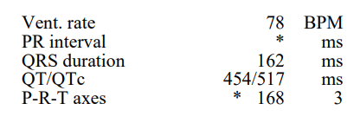
RR = 60 /HR (78 BPM)
RR = 0.769 s (769 ms)

QTc Interval (Bazett’s) = QT/$√RR$
QTc = 454/$√0.769$
QTc = 517 ms

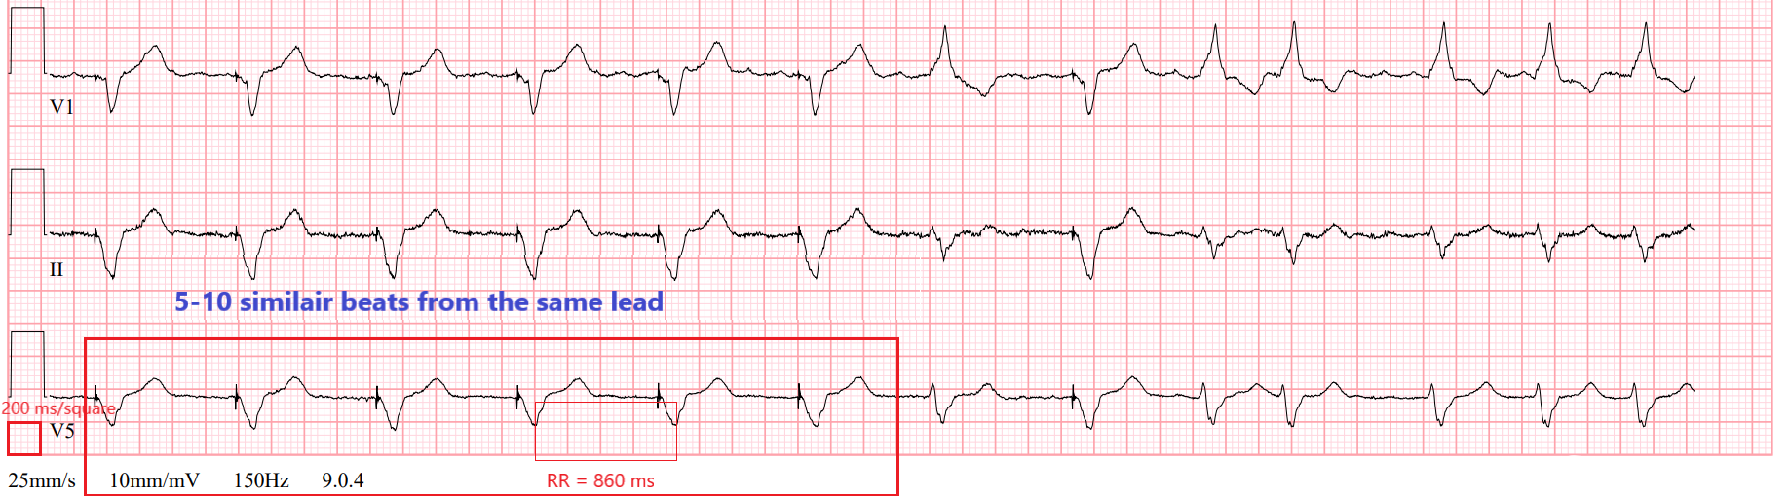

RR = 0.86 s (860 ms)

QTc Interval (Bazett’s) = QT/$√RR$
QTc = 454/$√0.860$
QTc = 490 ms

Provider Order:


Dofetilide QTc Prolongation Chart
Initial QTc (msec) | QTc Increased >15%
300 | 345
310 | 357
320 | 368
330 | 380
340 | 391
350 | 403
360 | 414
370 | 426
380 | 437
390 | 449
400 | 460
410 | 472
420 | 483
430 | 495
440 | 506
450 | 518
460 | 529
470 | 541
480 | 552
490 | 564
500 | 575
510 | 587
520 | 598
530 | 610
540 | 621

Appendix D
Drug Interactions and Contraindications:

The following medications are CONTRAINDICATED with dofetilide:
- Verapamil
- Hydrochlorothiazide (alone or in combination such as with triamterene)
- Cation transport inhibitors such as cimetidine, ketoconazole, trimethoprim (alone or in combination with sulfamethoxazole), prochlorperazine, megestrol, and dolutegravir.

Some Potential Drug Interactions with Dofetilide
(List is NOT all inclusive)
Medications that may prolong the QT interval | - Tricyclic antidepressants/Tetracyclic (maprotiline)  - Phenothiazines  - Cisapride  - Bepridil, Nicardipine  - Macrolides  - Antihistamines, etc.
Medications that are eliminated by the renal cation transport system | - Amiloride  - Metformin  - Triamterene
Inhibitors of CYP3A4 | - Cannabinoids  - Danazol  - Protease Inhibitors  - Diltiazem  - Macrolides  - Azole antifungal agents  - Serotonin Reuptake Inhibitors  - Grapefruit Juice  - Lefamulin  - Metronidazole  - Mirtazapine  - Nefazodone  - Norfloxacin  - Quinine  - Zafirlukast  - Zileuton
Medications that decrease K⁺ or Mg²⁺ | - Diuretics  - Corticosteroids  - β2-agonists  - High doses of cathartics and laxatives  - Amphotericin B  - Cisplatin, etc.

Appendix E

Dofetilide Discharge Procedures [Please coordinate with case management]:

For initial/continuing supply:
- Patients to be discharge on dofetilide therapy from an inpatient setting must have an adequate supply of dofetilide, at the patient’s individualized dose, to allow uninterrupted dosing until the patient can fill a dofetilide prescription.
- The hospital pharmacy at UConn John Dempsey Hospital will fill the adequate supply as deemed per circumstances at NO cost.
- Upon label generation for outpatient dispensing, it should be discontinued in pharmacy system so as not to appear as an inpatient order.
- The prescription should be filled in an amber medication vial with the appropriate outpatient labeling.
- Upon discharge it is also important to stress that the patient should take the exact dose and quantity as prescribed by the health care professional.

Appendix F

Dosing algorithm used in the TIKOSYN clinical program

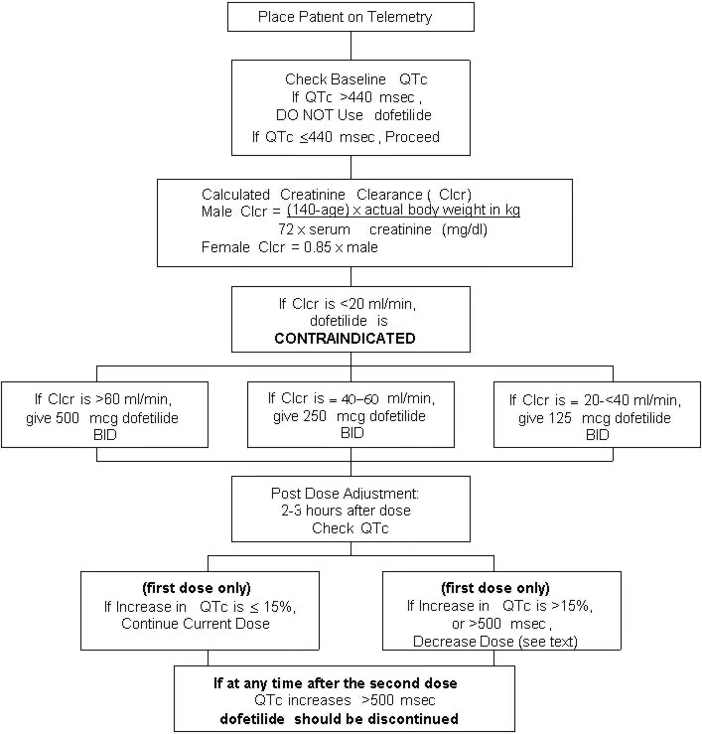

Appendix G

References

- Available at: http://www.tikosyn.com/. Accessed October 19, 2016

- Available at (Generic by Greenstone): http://www.greenstonellc.com/pdfs/USPI/Dofetilide%20USPI.PDF. Accessed October 19, 2016

- Available at http://www.fda.gov/Drugs/DrugSafety/PostmarketDrugSafetyInformationforPatientsandProviders/ucm489271.htm. Accessed September 29, 2016.

- Dofetilide. Circulation. 2000;102(21):2665.

- Falk RH, Decara JM. Dofetilide: a new pure class III antiarrhythmic agent. Am Heart J. 2000;140(5):697-706.

- Friedman L, Alexander E. Update of the clinical impact and issues surrounding Dofetilide (Tikosyn) therapy. AACN Adv Crit Care. 2006;17(2):102-8.

- Heijman J, Voigt N, Abu-taha IH, Dobrev D. Rhythm control of atrial fibrillation in heart failure. Heart Fail Clin. 2013;9(4):407-15, vii-viii.

- Roukoz H, Saliba W. Dofetilide: a new class III antiarrhythmic agent. Expert Rev Cardiovasc Ther. 2007;5(1):9-19.

- Saliba WI. Dofetilide (Tikosyn): a new drug to control atrial fibrillation. Cleve Clin J Med. 2001;68(4):353-63.

- Sullivan SD, Orme ME, Morais E, Mitchell SA. Interventions for the treatment of atrial fibrillation: a systematic literature review and meta-analysis. Int J Cardiol. 2013;165(2):229-36.

- Torp-Pedersen C., Moller M., Bloch-Thomsen P.E.; Dofetilide in patients with congestive heart failure and left ventricular dysfunction. Danish Investigations of Arrhythmia and Mortality on Dofetilide Study Group. N Engl J Med. 341 1999:857-865.

- Torp-Pedersen C., Moller M., Kober L., Camm A.J.; Dofetilide for the treatment of atrial fibrillation in patients with congestive heart failure. Eur Heart J. 21 2000:1204-1206.

- Singh S., Zoble R.G., Yellen L.; Efficacy and safety of oral dofetilide in converting to and maintaining sinus rhythm in patients with chronic atrial fibrillation or atrial flutter. the SAFIRE-D study. Circulation. 102 2000:2385-2390.

- Greenbaum RA, Campbell TJ, Channer KS, et al. Conversion of atrial fibrillation and maintenance of sinus rhythm by dofetilide. The EMERALD study (European and Australian Multicenter Evaluative Research on dtrail fibrillation Dofetilide) Study. [abstract]Circulation. 1998;98:1633

