PROTOCOL: Warfarin Collaborative Practice Dosing Protocol
CATEGORY: Clinical | Date Originated: 1/28/2015
Page 1 of 13 | Last Reviewed: 09/28/2022
Owner: Director of Pharmacy | Last Revised: 12/04/2019
Approved by: Pharmacy & Therapeutics Committee, Medical Staff Executive Committee | Retired:
Collaborative Practice Agreement for Warfarin drug management, dosing, and monitoring
- Scope:
- All Pharmacists who have received, completed, and passed the internal competency certification on warfarin clinical management.

- Population: Adult Inpatient (16 years old or greater) with orders for warfarin for specific indications detailed in this protocol. It will not include patients being treated with warfarin for status post orthopedic surgery. Patients status post orthopedic surgery, being continued on warfarin for another indication, may have warfarin dosed by pharmacy.

- Outcome: Pharmacists will independently manage daily warfarin therapy according to the guidelines detailed in this protocol
- Collaborative Practice Agreement
- Under this collaborative practice agreement, University of Connecticut Health Center / John Dempsey Hospital (UCHC/JDH) Pharmacists, according to and in compliance with Section 91 of Public Act 10-7 and Connecticut General Statutes sec 20-631 “An Act Concerning Collaborative Practice Between Physicians and Pharmacists”, may design, implement, and monitor a therapeutic drug plan intended to manage oral warfarin therapy upon receipt of an order from the licensed provider to the Pharmacist.

- The specific services provided by the Pharmacists and the methods for providing these services are described in detail in this document. These specific services are available to all adult inpatients (16 years old or greater).
- Purpose
- To establish collaboration between licensed providers and pharmacists for management of adult hospitalized inpatients receiving warfarin therapy using a standardized protocol based on current peer-reviewed literature.

- To maximize the therapeutic efficacy of oral warfarin therapy and to minimize the potential for adverse events.
- Procedures for warfarin Collaborative Practice Agreement
  - Patients initiated on warfarin while admitted to an Inpatient Care Unit

    - Pharmacists will have the ability to order a baseline PT/INR prior to initiation of warfarin therapy regardless of enrollment in the collaborative practice protocol. A PT/INR shall be done if no lab value within 3 days prior.

    - To initiate the protocol for inpatient, the patient’s appropriately-credentialed practitioner will select the “Warfarin Dosed per Collaborative Practice Protocol” order in the CPOE system.

      - Selection of Initial Warfarin Dose along indication and target range for treatment:

- As part of the “Warfarin Dosed per Collaborative Practice Protocol” order in the CPOE system, the practitioner will select an initial dose, warfarin indication and target range.
      - Responsibilities of Practitioner:
- Will maintain ability to order warfarin if desired, however, the practitioner will be expected to place an order in CPOE for “Warfarin Dosed per Practitioner”

- Will discontinue therapy if treatment options and/or plan of care change

- For the overall anticoagulation needs of the patient including non-warfarin therapy.

- If patient requires another form of anticoagulation (non-warfarin), such as unfractionated heparin or low molecular weight heparin, the provider is responsible for ordering non-warfarin therapy.

- Relay information to the pharmacist anytime there is a concern with the pharmacist’s management of the patient’s warfarin treatment

- Upon discharge, ordering outpatient INR (international normalized ratio) and providing prescription for warfarin
      - Pharmacist’s Responsibilities for “Warfarin Dosed per Collaborative
Practice Protocol”:
        - Will immediately assume the responsibility for assuring the patient’s
warfarin is dosed on a daily basis.

        - New consults will be performed daily 7:30am-3:30pm. When a new
consult is received between 3:30pm-7:30am, the pharmacist will
evaluate the first dose and if in their clinical judgment the dose is appropriate they will verify the order and the following day, the day shift
pharmacist will complete the consult.
        - Will have the ability to order lab work as related to warfarin treatment
- Pharmacist will order a PT/INR, CBC w/diff prior to initiation of warfarin therapy, if not already obtained.
- Subsequent INRs shall be ordered daily unless patient has stabilized. CBC w/diff can be ordered every 3 days if no results are available.
        - Determination of Warfarin Dose
- Pharmacists will review and collect the following patient data from thepatient’s medical record
- List of data to be collected;
  - Baseline INR
  - Daily INR
  - CBC w/diff
  - Interacting concomitant drug therapy
  - Albumin
  - Renal function
  - Previous warfarin history
  - H/H
  - Platelet
- This data is necessary to develop an optimized warfarin dose.
- Appendix II and III nomograms are to be used for the deciding initiation and continuation doses of warfarin therapy.
- Pharmacists shall check daily warfarin dose from previous day, related lab work (INR, Hemoglobin [HGB], Hematocrit [HCT], Platelets [PLT]), documentation of bleeding such as heme positive stool and/or urine, low blood pressure, drug interactions that may impact warfarin dosing.
        - Documentation of the Collaborative Practice Protocol in the Patient
Medical Record for Initial Consult:
- Pharmacists will document for the initial consult upon admission to the hospital or initiation of treatment in a progress note.
  - See Appendix IX for progress note that details what the pharmacist will review and the notification given to the provider.
- Pharmacists will document in the electronic health record (EHR) INR goal, indication for therapy, dose prior to admission (if applicable) and if a patient of the UCH Anticoagulation clinic. Other factors such as patient compliance and difficulties with therapy may also be documented.
        - Documentation of the Collaborative Practice Protocol in the Patient
Medical Record for Follow-Up Consults:
- Pharmacists will document daily for subsequent warfarin dosing via a progress note.
  - See Appendix X for progress note that details what the pharmacist will review and the notification given to the provider.
- Pharmacists will document the latest INR result, any related lab work, dose of warfarin and any other factors such as drug interactions that may impact warfarin therapy.
- Pharmacists will document in the online reporting system (Safety Intelligence) for any Adverse Drug Events as related to warfarin therapy (i.e. INR>5, clinically significant signs of thrombosis or bleeding).
        - Notification to practitioner
- Pharmacists will notify practitioner if:
  - INR>5
  - clinically significant signs of thrombosis or bleeding are reported
  - at any time further clarification of the clinical status of the patient is needed.
  - Initiation dose is adjusted dependent upon warfarin sensitivity.
- Whenever possible, the Pharmacist should also make an effort to provide a verbal summary of the key information related to warfarin to the patient’s practitioner and nursing provider(s).
- If a practitioner writes an order on a pharmacist managed patient, the pharmacist is expected to contact the practitioner to clarify.
        - Patient Education
- The pharmacist will provide education to the patient and/or caregiver daily 7:30am-3:30pm for a minimum of one visit starting on day 2 for new and continuation of warfarin therapy. The pharmacist will provide a written handout that is found on the UCH pharmacy website.
- The pharmacist will document in the EHR and pharmacy electronic system that education has been completed.

Appendix I: Target INR Goals and Duration of Treatment (tablet begins on next page)

Indication | Target INR | Duration
Deep Vein Thrombosis (DVT)/Pulmonary Embolism (PE)
Provoked (Transient risk factors) | 2.5 (2-3) | 3 months and reassess | DOACs preffered over VKA therapy and VKA therapy preferred over LMWH
Unproked | 2.5 (2-3) | 3 months and reassess | If PE, proximal DVT and pt at low to moderate risk of bleeding, extended anticoagulation therapy preferred over 3 months. High bleeding risk 3 months of anticoagulant preferred over extended therapy. Reassess need for extended therapy annually
Cancer | 2.5 (2-3) | Indefinite | Reassess annually, LMWH preferred
Upper Extrememity DVT w/unremoved central venous catheter | 2.5 (2-3) | Indefinite | As long as the central venous catheter remains
APAS or 2 or more thromophilic conditions | 2.5 (2-3) | Indefinite
Recurrent DVT/PE | 2.5 (2-3) | Indefinite | Reassess annually. Pts with high bleeding risk, recommend 3 months therapy over extended therapy. Pt’s on VKA therapy or DOAC and are compliant, LMWH preferred temporarily. Pt’s on LMWH and complaint recommended increasing dose of LMWH by one quarter to one third
Orthopedic Thromboprophylaxis
Hip Fracture Surgery (HFS) or Total Hip Arthroplasty (THA) | 2.5 (2-3) | At least 10 days and up to 35 days post op | LMWH preferred. For pts with increased bleeding risk use IPCD (Primary alternative= apixaban, dabigatran.  Secondary alternative = rivaroxaban or VKA)
Total Knee Arthroplasty (TKA) | 2.5 (2-3) | At least 10 days and up to 35 days post op | LMWH preferred. For pts with increased bleeding risk use IPCD (Primary alternative= apixaban, dabigatran.  Secondary alternative = rivaroxaban or VKA)
Atrial Fibrillation (AF) or Atrial Flutter (AFL)
CHA2DS2-VASc Score = 0 (Low risk of stroke) | No therapy | indefinite | Antiplatelet therapy alone no longer recommended
CHA2DS2-VASc Score = 1 (Intermediate risk of stroke) – Men only | 2.5 (2-3) | indefinite | Anticoagulation might be considered (IIB Recommendation)
CHA2DS2-VASc Score ≥ 2 (High risk of stroke) | 2.5 (2-3) | indefinite | Maintain TTR >70%. DOAC preferred over VKA, PTs on VKA with TTR <65% recommend intervention to improve TTR or switch to DOAC, Pt’s with prior GI bleed, Apixaban or Dabigatran 110mg BID preferred over other DOACs. Dabigatran 150mg BID recommended in pts at high risk of ischemic stroke
Mitral Stenosis | 2.5 (2-3) | indefinite
Pre-Cardioversion (AF or AFL ≥ 48 hours or unknown duration) | 2.5 (2-3) | 3 weeks | VKA or DOAC
Post-Cardioversion | 2.5 (2-3) | 4 weeks | VKA or DOAC; Decisions about anticoagulation beyond 4 weeks should be made in accordance with risk-based recommendations for long-term antithrombotic therapy
Secondary Prevention of Cardioembolic Stroke
History of ischemic stroke or TIA and AF | 2.5 (2-3) | Indefinite
Myocardial infarction (MI)
Anterior MI and LV thrombus or at high risk for LV thrombus (ejection fraction <40%, anteroapical wall motion abnormality) | 2.5 (2-3) | 3 months
Anterior MI and LV thrombus or at high risk for LV thrombus (ejection fraction <40%, anteroapical wall motion abnormality) undergo bare-metal stent | 2.5 (2-3) | 3 months
Anterior MI and LV thrombus or at high risk for LV thrombus (ejection fraction <40%, anteroapical wall motion abnormality) undergo drug-eluting stent | 2.5 (2-3) | 3-6 months
Systolic Left ventricular dysfunction with identified acute LV thrombus | 2.5 (2-3) | 3 months and reassess
Valvular Disease
Rheumatic mitral valve disease (w/ left atrial diameter >55mm, left atrial thrombus, afib or previous systemic embolism) | 2.5 (2-3) | indefinite | Rheumatic mitral valve disease pts with normal sinus rhythm and left atrial diameter < 55mm, no VKA is recommended
Rheumatic mitral valve disease undergoing percutaneous mitral balloon valvotomy (PMBV) with preprocedural TEE showing left atrial thrombus | 3 (2.5-3.5) | Until thrombus resolution is documented by repeat TEE | If the left atrial thrombus doesn’t resolve with VKA therapy, PMBV should not be preformed
Cryptogenic Stroke and Patent Foramen Ovale (PFO) or Atrial Septal Aneurysm
With recurrent event despite aspirin therapy | 2.5 (2-3) | indefinite | Consider of device closure
With evidence of DVT | 2.5 (2-3) | 3 months | Consider of device closure
Valve replacement – Bioprosthetic
Mitral | 2.5 (2-3) | 3 months | Followed by ASA in ps with normal sinus rhythm
Valve replacement – Mechanical
Aortic | 2.5 (2-3) | indefinite
Bileaflet or Medtronic Hall tilting disk | 2.5 (2-3) | indefinite
Ball and cage | 2.5 (2-3) | indefinite
Mitral | 3.0 (2.5-3.5) | indefinite
Bileaflet | 3.0 (2.5-3.5) | indefinite
Tilting disk | 3.0 (2.5-3.5) | indefinite
Ball and cage | 3.0 (2.5-3.5) | indefinite

Appendix II: Initial Dose Determination
- During Heparin/LMWH and warfarin overlap, start warfarin therapy on day 1 or 2 of heparin/LMWH therapy for improved outcomes in patients with acute VTE.
- When converting from parenteral heparin to warfarin for acute anticoagulation, the two should be overlapped for at least 5 days for VTE/DVT and until the INR is ≥ 2 for 24 hours or 2 days preferred. This may not be necessary when bridging for Afib or after surgery.
- Initial dosing should be tailored upon patient bleed risk, potential sensitivity to warfarin (see Appendix VI), indication with goal INR ranges (see Appendix I) and potential drug interactions (see Appendix VII).
- A baseline INR must be resulted prior to the verification of the first dose of warfarin.
- A current INR must be resulted prior to the verification of a warfarin dose adjustment.
- CBC should have a baseline result with rechecking a minimum of every 3 days thereafter.
- Warfarin should be adjusted based on current INR measurements. Prior to making a dose adjustment assess for any missed doses, drug interactions, diet, documentation of bleeding, or other changes that may affect INR.
- These are just dosage guidelines and the pharmacist should always incorporate their clinical judgment into the guideline to determine appropriate dose for the patient.

Target INR Goal of 2 -3
Day | Warfarin  Starting Dose (mg) | INR Value | Warfarin Increased Sensitivity  Starting Dose (mg)
Day 1 | 5 mg | < 1.5 | 2.5 mg
Day 2 | 5 mg | < 1.5 | 2.5 mg
Day 2 | 2.5mg | 1.5 – 1.9 | 1 – 1.5 mg
Day 2 | 1 – 2.5 mg | 2 – 2.5 | 0.5 – 1 mg
Day 2 | 0 mg | > 2.5 | 0 mg
Day 3 | 5 – 10 mg | < 1.5 | 2.5 – 5 mg
Day 3 | 2.5 – 5 mg | 1.5 – 1.9 | 1 – 2.5 mg
Day 3 | 0 – 2.5 mg | 2 – 3 | 0 – 1 mg
Day 3 | 0 mg | > 3 | 0 mg
Day 4 | 10 mg | < 1.5 | 5 mg
Day 4 | 5 – 7.5 mg | 1.5 – 1.9 | 3 – 5 mg
Day 4 | 0 – 5 mg | 2 - 3 | 0 – 2.5 mg
Day 4 | 0 mg | > 3 | 0 mg
Day 5 | 10 mg | < 1.5 | 5 mg
Day 5 | 7.5 – 10 mg | 1.5 – 1.9 | 3 – 5 mg
Day 5 | 0 – 5 mg | 2 - 3 | 0 – 2.5 mg
Day 5 | 0 mg | > 3 | 0 mg
Day 6 | 7.5 – 12.5 mg | < 1.5 | 3 – 7.5 mg
Day 6 | 5 – 10 mg | 1.5 – 1.9 | 2.5 – 5 mg
Day 6 | 0 – 7.5 mg | 2 – 3 | 0 – 4 mg
Day 6 | 0 mg | > 3 | 0 mg

Target INR Goal of 2.5 -3.5
Day | Warfarin  Starting Dose (mg) | INR Value | Warfarin Increased Sensitivity  Starting Dose (mg)
Day 1 | 5 mg | - | 2.5 mg
Day 2 | 5 mg | < 1.5 | 2.5 mg
Day 2 | 2.5 mg | 1.5 – 1.9 | 1 – 1.5 mg
Day 2 | 2.5 mg | 2 – 2.5 | 1 – 1.5 mg
Day 2 | 1 – 2.5 mg | 2.5 – 3 | 0.5 – 1 mg
Day 2 | 0.5 – 1 mg | 3 – 3.5 | 0.5 mg
Day 2 | 0 mg | > 3.5 | 0 mg
Day 3 | 5 – 10 mg | < 1.5 | 2.5 – 5 mg
Day 3 | 2.5 – 5 mg | 1.5 – 1.9 | 1 – 2.5 mg
Day 3 | 2.5 mg | 2 – 2.5 | 1.25 mg
Day 3 | 2.5 mg | 2.5 – 3 | 1.25 mg
Day 3 | 1 mg | 3 – 3.5 | 0.5 mg
Day 3 | 0 mg | > 3.5 | 0 mg
Day 4 | 10 mg | < 1.5 | 5 mg
Day 4 | 5 – 7.5 mg | 1.5 – 1.9 | 2.5 – 4 mg
Day 4 | 2.5 – 5 mg | 2 – 2.5 | 1.25 – 2.5 mg
Day 4 | 2.5 – 5 mg | 2.5 – 3.5 | 1 – 2.5 mg
Day 4 | 0 mg | > 3.5 | 0 mg
Day 5 | 10 mg | < 1.5 | 5 mg
Day 5 | 7.5 – 10 mg | 1.5 – 1.9 | 3 – 5 mg
Day 5 | 0 – 5 mg | 2 – 2.5 | 2.5 mg
Day 5 | 2.5 – 5 mg | 2.5 – 3.5 | 1.25 – 2.5 mg
Day 5 | 0 mg | > 3.5 | 0 mg
Day 6 | 7.5 – 12.5 mg | < 1.5 | 4 - 6 mg
Day 6 | 5 – 10 mg | 1.5 – 1.9 | 2.5 - 5 mg
Day 6 | 5 – 7.5 mg | 2 – 2.5 | 2.5 - 4 mg
Day 6 | 2.5 – 7.5 mg | 2.5 – 3.5 | 1.25 - 4 mg
Day 6 | 0 mg | > 3.5 | 0 mg

Appendix III: Warfarin Maintenance Dosing
- If the patient is currently managed by the UCH Anticoagulation clinic and the INR is within the target range, evaluate the patient for any changes in co-morbidity, warfarin sensitivity, warfarin clearance or potential drug interactions. If there are no changes, continue the dose as prescribed by the clinic and monitor the patient daily. If there are changes, evaluate the patient for a dosage change and try to identify the reason for current INR value.
- For patients on warfarin prior to admission their home dose may be used if appropriate.
- Warfarin should be adjusted based on current INR measurements. Prior to making a dose adjustment assess for any missed doses, drug interactions, diet, documentation of bleeding, or other changes that may affect INR.
- CBC should have a baseline result with rechecking a minimum of every 3 days thereafter.
- A baseline INR must be resulted prior to the verification of the first dose of warfarin.
- Obtain daily INR values unless the patient has been maintained on the same warfarin dose during inpatient admission and no changes in INR from target goal.
- Increased dietary intake of vitamin K can reduce the anticoagulation effect of warfarin.
- These are just dosage guidelines and the pharmacist should always incorporate their clinical judgment into the guideline to determine appropriate dose for the patient.

Continuation of Therapy: Warfarin Maintenance Dosing
Target INR 2 - 3 | Dosing Adjustment | Target INR 2.5-3.5
INR < 1.5 | - consider booster dose of 1.5-2 times daily maintenance dose  - consider resumption of prior maintenance dose if factor causing decreased INR is transient, (i.e. missed warfarin doses)  - if dosage adjustment is needed increase maintenance dose by 10-20% | INR < 2
INR 1.5 - 1.7 | - consider booster dose of 1.5-2 times daily maintenance dose  - consider resumption of prior maintenance dose if factor causing decreased INR is transient, (i.e. missed warfarin doses)  - if dosage adjustment is needed, increase maintenance dose by 5-15% | INR 2-2.3
INR 1.8 - 1.9 | - no dosage adjustment may be necessary: if the last two INR’s were in range, if there is no clear explanation for the INR to be out of range and if in the judgment of the clinician the INR does not represent an increased risk of thromboembolism for the patient  - consider booster dose of 1.5-2 times daily maintenance dose  - consider resumption of prior maintenance dose if factor causing decreased INR is transient, (i.e. missed warfarin doses)  - if dosage adjustment is needed, increase maintenance dose by 5-10% | INR 2.3-2.4
Target INR 2 - 3 | No dosing adjustment needed | Target INR 2.5 - 3.5
INR 3.1 - 3.2 | - no dosage adjustment may be necessary: if the last two INRs were in range, if there is no clear explanation for the INR to be out of range, and if in the judgment of the clinician, the INR does not represent an increased risk of hemorrhage for the patient  - consider continuation of prior maintenance dose if reason for elevated INR is transient (i.e. acute alcohol ingestion)  - if a dosage adjustment is needed, decrease maintenance dose by 5-10% | INR 3.6 - 3.7
INR 3.3 - 3.4 | - consider holding 1 dose  - consider resumption of prior maintenance dose if reason for elevated INR is transient (i.e. acute alcohol ingestion)  - if a dosage adjustment is needed, decrease maintenance dose by 10-20% | INR 3.8 - 3.9
INR 3.5 - 3.9 | - consider holding 1 dose  - consider resumption of prior maintenance dose if reason for elevated INR is transient (i.e. acute alcohol ingestion)  - if a dosage adjustment is needed, decrease maintenance dose by 5-15% | INR 4 - 4.4
INR > 4 | - hold warfarin until INR < upper limit of target range  - consult provider if warfarin reversal may be indicated  - consider resumption of prior maintenance dose if reason for elevated INR is transient (i.e. acute alcohol ingestion)  - if a dosage adjustment is needed, decrease maintenance dose by 5-15% | INR > 4.5

Appendix V: Warfarin Reversal Recommendations/Guidelines
No reversal agent is to be initiated without a direct order from the independently licensed practitioner.
- FFP has the disadvantage of potential allergic reaction or transmission of infection, preparation time and higher volume. FFP onset of action 1-4 hours and duration of action 6 hours.
- PCC (Kcentra®) is more rapidly concentrated and infection transmission risk but have not been compared with FFP in adequately powered studies. Chest recommends four-factor PCC rather than plasma. Onset of action of 10-15 minutes and duration of action 12-24 hours.
NOTE: we currently have formulary restricted to Neurosurgery and HEME/ONC (consult).
- Vitamin K must be given concurrently with Kcentra®
- If INR over-corrected, may have to consider Heparin or LMWH until INR therapeutic
- Intravenous Vitamin K works faster than oral vitamin K, but is associated with anaphylactoid reaction in 3/10,000 patients. Low dose Vitamin K reduces an INR of 6-10 to less than 4 in 1.4 days after PO and 24 hours after intravenous. High dose Vitamin K begins reducing INR within 2 hours with a correction to normal generally by 24 hours.
- Subcutaneous injection not recommended; effect is delayed and unpredictable.

Chest 2012 Guidelines
INR | Recommendation if Rapid Reversal is NOT necessary
4.5-10, no evidence of bleeding | Hold Anticoagulation. Vitamin K not routinely recommended if no evidence of bleeding.
>10, no evidence of bleeding | Hold Anticoagulation and Vitamin K 2.5-5mg PO. May need to repeat Vitamin K dose in 24 to 48 hours
INR | Rapid Reversal Indicated
Elevated, with need for urgent (but not lifesaving) procedure | Hold anticoagulation, give Vitamin K 2.5-5mg PO
Elevated, with non-life-threatening bleeding | Hold anticoagulation, give Vitamin K 5-10mg IV, give FFP (consider Kcentra®)
Elevated, with need for lifesaving procedure | Hold anticoagulation, give Vitamin K 5-10mg IV, give Kcentra®
Elevated, with life-threatening, major bleeding | Hold anticoagulation, give Vitamin K 5-10mg IV, give Kcentra®

Appendix VI: Warfarin Sensitivity
- Patients with multiple high sensitivity risk factors may require a lower initiation dose and reduced maintenance doses.
- Warfarin is a drug with high protein binding. Up to 99% of the drug is bound to plasma proteins. Patients who are malnourished with low albumins will have higher concentration of unbound drug.
Increased Warfarin Sensitivity
Increased INR Response | Increased Bleeding Risk
- Baseline INR ≥ 1.5  - Age > 65  - Actual body weight < 45 kg or actual < ideal  - Malnourished/NPO > 3 days  - Hypoalbuminemia < 2 g/dL  - Chronic diarrhea  - Significant drug interactions  - Decompensated heart failure  - Asian race  - Malignancy | - Current antiplatelet therapy  - Thrombocytopenia: platelet < 75 K/uL  - Significant hepatic disease: cirrhosis or total bilirubin > 2.4mg/dL  - Alcohol abuse history  - End stage renal disease  - GI bleed within past 30 days  - Surgery within past 2 weeks  - Intracranial bleed within past 30 days

Appendix VII: Drug/Food Interactions
- Most drug interactions with warfarin will start to have an effect within 3-5 days of concomitant therapy. There are some notable exceptions which include amiodarone, carbamazepine and rifampin which will start to have an effect within 7-14 days of dual therapy. For most interactions a total weekly dose adjustment of either an increase or decrease of 30% is needed. There are some notable exceptions which included amiodarone which needs a total weekly dose decrease of 50% and rifampin which needs a total weekly dose increase of 50%.
- Some experts advise holding nutrition formulas for 1–2 hours before and after warfarin to avoid interactions. Not all experts agree in the nature of the interaction or the need to hold nutrition. In many cases adequate dilution and rinsing will avoid this interaction so do not hold nutrition formulas. Patients receiving enteral nutrition will have more bound drug to plasma proteins due to high protein concentration in these products.

Medications, dietary supplements and food that INCREASE INR or bleeding risk
Drug Class | Known Interaction | Probable Interaction | Possible Interaction | Unlikely Interaction
Anti-infective | Ciprofloxacin  Erythromycin  Fluconazole  Isoniazid  Metronidazole  Miconazole  Miconazole Vaginal Suppository  Moxifloxacin  Sulfamethoxazole  Voriconazole | Amoxicillin/clavulanate  Azithromycin  Clarithromycin  Itraconazole  Ketoconazole  Levofloxacin  Ritonavir  Tetracycline | Amoxicillin  Chloramphenicol  Darunavir  Daptomycin  Etravirine  Ivermectin  Miconazole topical gel  Nitrofurantoin  Norfloxacin  Ofloxacin  Saquinvair  Telithromycin  Terbinafine | Cefotetan  Cefazolin  Tigecycline
Cardiovascular | Amiodarone  Clofibrate  Diltiazem  Fenofibrate  Propafenone  Propranolol | Aspirin  Fluvastatin  Quinidine  Ropinirole  Simvastatin | Disopyramide  Gemfibrozil  Metolazone | Heparin
Analgesics, Anti-inflammatory | Piroxicam | Acetaminophen  Aspirin  Celecoxib  Tramadol | Indomethacin  Proproxyphene  Sulindac  Tolmentin  Topical Salicylates | Methylprednisolone  Nabumetone
CNS Drugs | Alcohol  Citalopram  Entacapone  Sertraline | Disulfiram  Chloral Hydrate  Fluvoxamine  Phenytoin | Felbamate | Diazepam  Fluoxetine  Quetiapine
GI Drugs and Food | Cimetidine  Mango  Omeprazole | Grapefruit | Orlistat
Herbal Supplement | Fenugreek  Feverfew  Fish Oil  Ginkgo  Quilinggao | Dandelion  Danshen  Don Quai  Lycium  PC-SPES  Red or Sweet Clover | Capsicum  Forskolin  Garlic  Turmeric
Other | Anabolic Steroids  Capecitabine  Zileutin | Fluorouracil  Gemcitabine  Levamisaole  Paclitaxel  Tamoxifen  Tolterodine | Acarbose  Cyclophosphamide  Danazol  Iphosphamide  Trastuzumab | Etoposide  Carboplatin  Levonorgestrel

Medications, dietary supplements and food that DECREASE INR or bleeding risk
Drug Class | Known Interaction | Probable Interaction | Possible Interaction | Unlikely Interaction
Anti-infective | Griseofulvin  Nafcillin  Ribavirin  Rifampin | Dicloxacillin  Ritonavir  Rifapentine | Terbinafine  Nelfinavir  Nevirapine | Cloxacillin  Rifaximin  Teicoplanin
Cardiovascular | Cholestyramine | Bosentan | Telmisartan | Furosemide
Analgesics, Anti-inflammatory | Mesalamine | Azathioprine | Sulfasalazine
CNS Drugs | Barbiturates  Carbamazepine | Chlordiazepoxide |  | Propofol
GI Drugs and Food | High content vitamin K food  Avocado | Soy milk  Sucralfate | Sushi containing seaweed
Herbal Supplement | Alfalfa | Ginseng  Multivitamin  St. John’s Wort  Parsley | Co-Enzyme Q10  Yarrow  Licorice | Green Tea
Other | Marcaptopurine | Chelation Therapy  Influenza vaccine  Raloxifene | Cyclosporine  Etretinate  Ubidecarenone

Appendix VIII: CHA₂DS₂-VASc and ^{c} HAS-BLED Scores
ª CHA₂DS₂-VASc: 1 point for presence of Congestive heart failure, Hypertension, Diabetes, Vascular disease, Age 65-74, and sex category female, and 2 points for Age ≥75 and prior Stroke or TIA.
^{b} Patients may be also considered high thromboembolic risk in the following scenarios and bridging should be considered
- Prior stroke or TIA occurring >3 months before the planned surgery and a CHA2DS2-VASc score <5
- Prior thromboembolism during temporary interruption warfarin
- Patient with remote (>1 year ago), severe VTE with resultant pulmonary hypertension
- Surgery associated with an increased risk for stroke or other thromboembolism (i.e. cardiac valve replacement, carotid endarterectomy, major vascular surgery) ** In the above patients at high risk for thromboembolism AND undergoing high-bleeding risk procedures (major cardiac surgery, carotid endarterectomy surgery), it is not unreasonable to consider no bridging.
^{c} HAS-BLED: 1 point for presence of Hypertension, renal disease [dialysis, transplant, SCr >2.26 mg/dL], liver disease [cirrhosis or bilirubin >2x normal with AST/ALT >3x normal], stroke, prior major bleeding or predisposition to bleeding, labile INR or TTR <60%, age >65, medication use predisposing to bleeding [aspirin, clopidogrel, NSAID usage], alcohol use ≥8 drinks/week

Appendix IX: Initial Warfarin Dosing per Collaborative Practice Protocol Progress Note
UCONN RX WARFARIN INITIAL DOSING NOTE (15157)
Pharmacy: Initial Warfarin Dosing

@NAME@ is a @AGE@ @SEX@ being treated with warfarin for {UCONN RX WARFARIN INDICATION FOR ANTICOAGULATION:26792}. The target INR for warfarin therapy is {UCONN INR CLINIC:24905}.

Patient {is/is not:27195} new to Warfarin therapy. Patient {is/is not:27195} a UConn Health Anticoagulation Clinic patient.

Home Dose: {UCONN RX WARFARIN DOSE SCHEDULE:30263}

INR: @BRIEFLAB(INR:7,2)@
HGB: @LASTLAB(HGB:3,2)@
HCT: @LASTLAB(HCT:3,2)@
PLT: @LASTLAB(PLT:3,2)@
Albumin: @LASTLAB(ALBUMIN:2)@
ALT: @LASTLAB(ALT:2)@
AST: @LASTLAB(AST:2)@

Warfarin Dosing Considerations: {UCONN RX WARFARIN DOSING CONSDERATIONS:26795}

Additional Anticoagulants: {UCONN RX ADDITIONAL ANTICOAGULANTS:30269}

Potential Drug Interactions: {UCONN RX WARFARIN DRUG INTERACTIONS:30274}

Plan:
Warfarin *** mg tonight at 1800 @TD@

Additional Comments: INR ordered for tomorrow with AM labs. Verified with nursing that patient has no signs or symptoms of bleeding or planned procedure. Pharmacy will continue to monitor daily and if indicated, adjust dose and/or frequency, order lab work as appropriate per the Pharmacy and Therapeutics Committee approved collaborative practice.

Assessment completed by:
@ME@ @TD@ at @NOW@

Collaborative Practice Agreement found here:
https://health.uconn.edu/pharmacy/staff - references/anticoagulation - heparin - resources/warfarin - collaborative - practice/
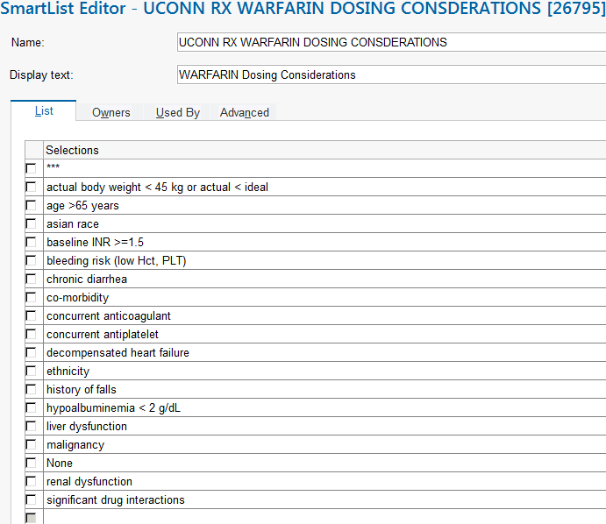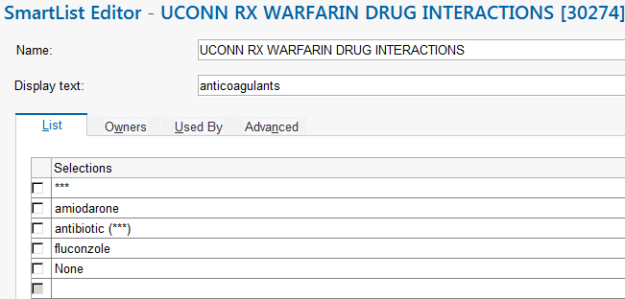

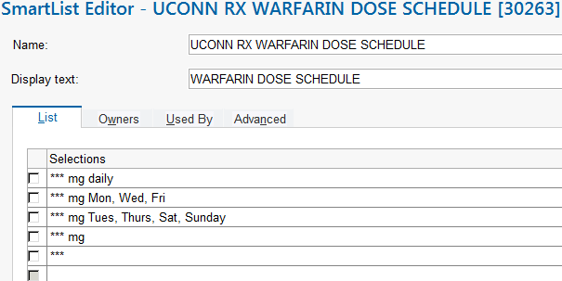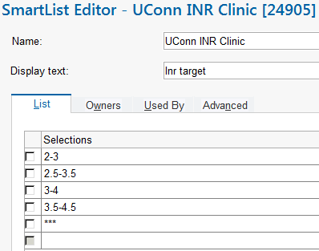
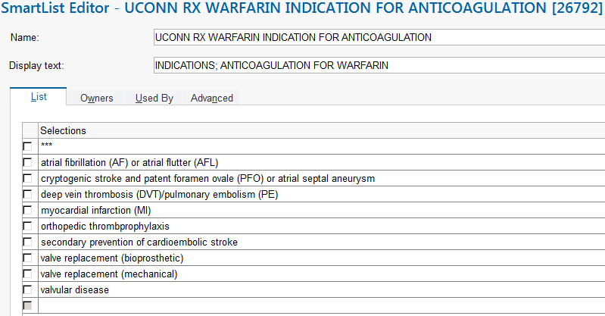
Appendix X: Follow-Up Warfarin Dosing per Collaborative Practice Protocol Progress Note
Plan:
Warfarin *** mg tonight at 1800 @TD@
Additional Comments: INR ordered for tomorrow with AM labs. Verified with nursing that patient has no signs or symptoms of bleeding or planned procedure. Pharmacy will continue to monitor daily and if indicated, adjust dose and/or frequency, order lab work as appropriate per the Pharmacy and Therapeutics Committee approved collaborative practice.

Assessment completed by:
@ME@ @TD@ at @NOW@

Collaborative Practice Agreement found here:
https://health.uconn.edu/pharmacy/staff - references/anticoagulation - heparin - resources/warfarin - collaborative - practice/
References
- Ageno W, Gallus A, Wittkowsky A, et al. American College of Chest Physicians. Oral anticoagulation therapy: American College of Chest Physicians Evidence-Based Clinical Practice Guidelines (9th Edition). Chest 2012; 141:44S-88S.
- Antithrombotic Therapy and Prevention of Thrombosis, 9th ed: American College of Chest Physicians Evidence-Based Clinical Practice Guidelines. Chest 2012; 141:1S-801S.
- Capodanno D, Angiolillo DJ. Antithrombotic therapy in patients with chronic kidney disease. Circulation 2012; 125:2649-61.
- Cavallari LH, Shin J, Perera MA. Role of Pharmacogenomics in the Management of Traditional and Novel Oral Anticoagulants. Pharmacotherapy 2011; 31(12):1192–1207.
- Crowther M et al. Less may be better. Ann Int Med 1997; 127:332-333.
- Fowlers S, Gulseth M, Renier C, et al. Inpatient warfarin: experience with a pharmacist-led anticoagulation management service in a tertiary care medical center. Am J Health-Syst Pharm. 2012; 69:44-48.
- Garwood CL, Hwang JM, Mower LR. Striking a balance between the risks and benefits of anticoagulation bridge therapy in patients with atrial fibrillation: clinical updates and remaining controversies. Pharmacotherapy 2011; 31:1208-1220.
- Harrison L et al. Comparison of 5 mg and 10 mg loading doses on initiation of warfarin therapy. Ann Int Med 1997; 126:133-136.
- Hickey M, Gatien M, Taljaard M et al. Outcomes of Urgent Warfarin. Circulation 2013; 128:360-364.
- Kalus JS. Pharmacologic interventions for reversing the effects of oral anticoagulants. Am J Health-Syst Pharm. 2013; 70(Suppl1):S12-21.
- Limdi NA, Limdi MA, Cavallari et al. Warfarin dosing in patients with impaired kidney function. Am J Kidney Dis 2010; 56:823-31.
- Thigpen JL, Limdi NA. Reversal of oral anticoagulation. Pharmacotherapy 2013; 33:1199-1213.
- University of Washington Medical Center (UWMC) Anticoagulation Services, www.uwmcacc.org
- University of Washington Warfarin Maintenance Dosing Nomogram © 2013 http://depts.washington.edu/anticoag/home/content/warfarin-maintenance-dosing-nomogram Date Accessed: January 23, 2015
- Wellman JC, Kraus PS, Burton BL et al. Development and implementation of a pharmacist-managed inpatient anticoagulation monitoring program. Am J Health-Syst Pharm. 2011; 68:934-9.
- Wittkowsky A. Warfarin (AHFS 20:12.04). In: Murphy JE, ed. Clinical Pharmacokinetics, Bethesda, MD: American Society of Health-System Pharmacists, 4th ed, 2008.
- Wittkowsky AK, Spinler SS, Dager W et al. Dosing guidelines, not protocols for managing warfarin therapy. Am J Health-Syst Pharm 2010; 67:1554-6.
- Wittkowsky AK. Novel Oral Anticoagulants and Their Role in Clinical Practice. Pharmacotherapy 2011; 31(12):1175–1191.

Approved by the UCHC Pharmacy & Therapeutics Committee on __January 28, 2015___. This service constitutes agreement by the provider with this collaborative practice agreement and satisfies all state legal requirements of a pharmacist collaborative practice agreement. Under Connecticut State law and CMS requirement the collaborative practice agreement and referral must be renewed yearly by the Pharmacy and Therapeutics Committee by signing a new agreement.

Medical Director Signature:________________________________Date:_______________

PCP/ReferringLIP______________________________________Date:_______________

